HOLY ROSARY INDEPENDENT COMBINED SCHOOL


2026

SCHOOL FEES STRUCTURE YEAR 2026
LEVEL | MONTHLY | QUARTERLY SCHOOLFEES | TEXTBOOK LEVY | TOTAL TERMLY FEES
Creche | R1540.00 | R4620.00 | R0.00 | R4620.00
Grade 0 | R1040.00 | R3120.00 | R0.00 | R3120.00
Grade R  10% discount  15% discount | R1200.00  R1080.00  R1020.00 | R3600.00  R3240.00  R3060.00 | R0.00  R0.00  R0.00 | R3600.00  R3240.00  R3060.00
Grade 1-3  10% discount  15% discount | R1650.00  R1485.00  R1405.00 | R4950.00  R4455.00  R4215.00 | R150.00  R150.00  R150.00 | R5100.00  R4605.00  R4365.00
Grade 4-6  10% discount  15% discount | R1750.00  R1575.00  R1490.00 | R5250.00  R4725.00  R4470.00 | R150.00  R150.00  R150.00 | R5400.00  R4875.00  R4620.00
Grade 7-9  10% discount  15% discount | R1840.00  R1660.00  R1565.00 | R5520.00  R4980.00  R4695.00 | R250.00  R250.00  R250.00 | R5770.00  R5230.00  R4945.00
Grade 10-12 | R2002.00 | R6006.00 | R400.00 | R6406.00
- Registration & Re-registration Fees R600.00/annum non-refundable.
- 2nd and 3rd child discount will only be applicable if school fees is paid timeously.
- Creche fees include meals
♦ School Banking Details:
Account Holder: Holy Rosary Independent School
Bank Name & Account: FNB 62012081634
Branch Code: 260649
Reference: Learner’s full names and grade

A 5% cash discount will be given for annual fees paid by 28th February 2026.

School Fees must be paid quarterly at the beginning of each term or strictly on a monthly basis by the 7th of each month, making sure that fees are fully settled within the quarter.

UNIFORM PRICE LIST

Item | Gr.0-6 | Gr. 7-12
Shirt | R220.00 | R240.00
Jersey | R230.00 | R260.00
Pullover | R220.00 | R260.00
Long trousers | R220.00 | R260.00
Tracksuit | R350.00  R500.00 | R350.00  R600.00
Socks | R50.00 | R50.00
Tunic | R340.00 | ***
T-shirt(Sports/P.E) | R120.00 | R140.00
Shorts | R100.00 | R100.00
Summer Hat | R70.00 | R70.00
Winter Hat  School Caps | R80.00  R50.00 | R80.00  R50.00
Skirts | *** | R195.00
FET Blazer |  | R 850.00
Drymac | R350.00 | R365.00
UNIFORM

KEY POINTS TO NOTE ON SCHOOL UNIFORM
- Full uniform is worn from Monday-Thursday, Casual Friday-R2.00. Grade 0 to 6 girls must put on plain white shirt with the tracksuit. The Uniform may not be worn with Casual clothes.
- Beanies or hoodies are only acceptable during the winter season.
- Tunics and skirts must be of an acceptable length, no shorter than 10cm above the knee. Skirts are available in the school. Slacks or trousers are not part of the girls’ school uniform at Holy Rosary School.
- No jeans or casual trousers (Chinos) are allowed. Boys must wear the correct and decently sized pair of trousers that fits well. The width of the trousers may not be adjusted to make skinny pants. Baggy and drop-down trousers are not allowed.
- No school uniform maybe worn for physical education lessons and sporting activities.
- It is compulsory that the boy’s hair should be trimmed to brush size.
- The correct uniform and correct maroon colour is available in the school.

STATIONERY LIST

F.E.T (GRADE 10, 11, 12)

COMPULSORY
5 x 192 feint 30 cm ruler
3 x 288 feint Sharpener
4 x 288 Quad (6 for Gr.12) Hi- lighters pack
3 x 72 feint 50 pages’ pocket folder
1 Dictionary 1 Butterfly book 50 pages
1 English handbook and study guide pair of scissors
1 Scientific calculator 4 x 43g glue stick pritt only
1 Mathematical Set 1 pad lock
Black / Blue pens 7 flat files
pencils Eraser
3 Exam pads 100 pages
2 Reams A4 Typek bond paper 500 sheets
1 x10 pkt Ritebrand single ply toilet tissues
SCIENCE STREAM  COMPULSORY  1.Dustcoat (white)  2.A pair of goggles  3.Rubber gloves  4. Dust mask  LIFE SCIENCES  1 X 288 feint A4  1 X 72 feint A4  PHYSICAL SCIENCES  1 x 288 feint A4  1 X 72 feint A4  GEOGRAPHY  1x 288 feint A4  1X 72 feint A4 | COMMERCIAL STREAM  ACCOUNTING  1 x 192 ledger  1 x 192 journal  1 x 192 feint A4  1 x 72 feint A4  BUSINESS  1 X 192 feint A4  1 x 72 feint A4  ECONOMICS  1 x 192 feint A4  1 x 72 feint A4
Holy Rosary School is a home, a school, a church and a playground.
Grade 9  1 pocket folder 50 pages  6 Feint A4books 72 pages  2 Quad A4 books 288 pages  1 Quad A4 book 72 pages  5 Feint A4 books 288 pages  5 Feint A4 books 32 pages  6 Feint A4 books 192 pages  10 blue or black pens  4HBpencils, 4 sharpeners, 2 erasers, 1 pair of scissors & 2 rulers  2 packets twister crayons  2 glue sticks / per term  1 set Mathematical instrument  1 packet highlighters  13 flat files  Dictionary- English (Oxford 8 -12)  1 butterfly coloured 50 pages  Dustcoat, goggles, rubber gloves, dust mask  1 English handbook &Study Guide  1 Scientific Calculator  3 Exam pads 100 pages  2 Reams A4 Typek bond paper 500 sheets  1pkt x10 Ritebrand single ply 500 sheets toilet tissues | Grade 8  1 pocket folder 50 pages  6 Feint A4books 72 pages  2 Quad A4 books 288 pages  5 Feint A4 books 288 pages  5 Feint A4 books 32 pages  6 Feint A4 books 192 pages  8 blue or black pens  4 HB pencils, 4 sharpeners, 2 erasers, 1 pair of scissors & 2 rulers  2 packets twister crayons  2 glue sticks / per term  1 set Mathematical instrument  1 packet highlighters  13 flat files  1 dictionary English (Oxford 8 – 12)  1 butterfly coloured 50 pages  Dustcoat, goggles, rubber gloves, dust mask  1 English handbook &Study Guide  1 Quad A4 book 72 pages  3 Exam pads 100 pages  2 Reams A4Typek bond paper 500 sheets  1pkt x10 Ritebrand single ply 500 sheets toilet tissues | Grade 7  1 pocket folder 50 pages  6 Feint A4books 72 pages  2 x3Quire Quad A4 books 288 pages  5 Feint A4 books 288 pages  5 Feint A4 books 32 pages  6 Feint A4 books 192 pages  10 blue or black pens  4 HB pencils, 4 sharpeners, 2 erasers, 1 pair of scissors & 2 rulers  2 packets twister crayons  2 glue sticks / per term  1 set Mathematical instrument  1 packet highlighters  13 flat files  1 dictionary English  3 butterfly coloured 50pgs  1 English handbook & Study Guide  1 Exam pads 100 pages  2 Reams A4 Typek bond paper 500 sheets  1pkt x10 Ritebrand single ply 500 sheets toilet tissues

“CATHOLIC SCHOOLS PREPARE EVERY STUDENT TO MEET THE CHALLENGES OF THE FUTURE, BY DEVELOPING THEIR MIND, YES, BUT ALSO THEIR BODY AND SOUL AND SPIRIT”
Grade 6  10 X feint margin 192  2 X192 pages Quad  8 feint margin X 72 pages  1 Diary Dictionary: English  4 blue or black pens  2 HB pencils, 4 sharpeners, 2 erasers,  50page butterfly pad  pair of scissors & 2 rulers  2 packets twister crayons  2 glue sticks Pritt only  1 packet highlighters  7 Flat files  2 Reams A4 Typek bond paper 500 sheets  1 English handbook &Study Guide  English and Xitsonga Dictionary  1 Exam pads 100 pages  1pkt x10 Ritebrand single ply 500sheets toilet tissues | Grade 5  7x 2 Quire feint pages  7x 72-page feint  2x 2 Quire Quad  1x 72 pages Quad  7 quotation folders  1 Unruled A4 72 pages  10 blue or black pens  Dictionary: English  6 HB pencils, 4 sharpeners, rubbers, pair of scissors & rulers  3 packets twister crayons  4 glue sticks Pritt only  1 packet highlighters  1 English handbook and study guide  2 Reams A4 Type bond paper 500 sheet  English and Xitsonga Dictionary  1 Exam pads 100 pages  1pkt x10 Ritebrand single ply 500sheets toilet tissues  50page butterfly pad | Grade 4  7 X 3 Quire feint margin 192 pgs  2X 3 Quire quad margin 192 pgs  7x 72 pages’ feint margin  7 pocket file 30 flip  Dictionary: English  1 A4 drawing book  1 Diary  10 HB pencil, 4 sharpeners, 4 rubbers, 4 pair of scissors & 6 rulers  4 packets twister crayons  4 glue sticks Pritt only  2 manila sheets (big)  1 packet highlighters  2 Reams A4 Typek bond paper 500 sheets  English and Xitsonga Dictionary  1 Exam pads 100 pages  1pkt x10 Ritebrand single ply 500 sheets toilet tissues
Grade 3  10 Feint A4 books 72 pages  4 Quad A4 books 72 pages  2 Irish Margin A4 books 72page  1 Unruled A4 72 pages  Dictionary: English  4 HB pencils  1 sharpener 1 rubbers, 1 pair of scissors & 2 rulers  2 packets twister crayons  2 glue sticks Pritt only  1 packet highlighters  1 C-thru display file 20 pages  4 flat files, 1 A5 quire  2 Reams A4 Typek bond paper 500 sheets  1pkt x10 Ritebrand single ply 500 sheets toilet tissues | Grade 2  1 Arch lever file  3 C-thru display file 50 pockets  12 Irish margin A4 book 72pg  1 A5 quire  6 quad A4 books 72 pages  1 unruled A4 books 72 pages  30 HB pencils only  2 sharpeners,2 rubbers, 2 rulers, 1 pair of scissors  4 packets twisters crayons  8 X 43g glue sticks print only  1 butterfly Coloured Book  2 Reams A4 Typek bond paper 500 sheets  1pkt x10 Ritebrand single ply 500sheets toilet tissues | Grade 1  4 C-THRU files (50 pocket)  4 quad A4 books 72 pages  15 Irish A4 72pages book  1 unruled A4 books 72 pages  80 green pencils per year  4 sharpeners, 4 rubbers, 2 rulers  1 pair of scissors  4 packets twisters’ crayons  8 x 43g glue sticks Pritt only  2 butterfly coloured book  (1 hard & 1 Soft)  1 set water paint, 1 paint brush  5 flat files, 1 A5 quire  2 Reams A4 Typek bond paper 500 sheets  1pkt x10 Ritebrand single ply 500sheets toilet tissues

Matric Results

Year 2022: Pass Rate 95% (20 learners)
Year 2023: Pass Rate 85.2% (27 learners)
Year 2024: Pass Rate 97% (33 learners)

Grade R  3 C-thru display file 50 pockets  1 Irish Margin A4 72 pages  6 Feint A4 books 72 pages  2 Feint A5 72 pages  6 Quad A4 books 72 pages  1 Feint A5 quire  2 sharpeners  1 pair of scissors  4 packets twisters’ crayons  6 x 43g glue sticks Pritt only  1 bucket molding clay  2 butterfly coloured book 50 pages (1hard&1 soft)  2 HB pencils comfort grip  10 HB pencils  2 rulers  1x 10/15 pieces puzzle  1 packet of Wet Wipes  1 Tablet 10 inch screen  1 Apron  2 Reams A4 Typek bond paper 500 sheets  1pkt x10 Ritebrand single ply 500sheets toilet tissues | Grade 0  5 C-thru display file 50 pockets  4 Feint A5 books 72 pages  4 Feint A4 72 pages  2 Quad A5 books 72 pages  2 Quad A4 book 72 pages  4 HB pencils comfort grip  1 pack Jumbo Wax  1 pair of scissors  3 packets twisters’ crayons  6 x 43g glue sticks Pritt  1 bucket molding clay  1 Feint A5 quire  2 butterfly coloured book  1x 5/10 pieces puzzles  1 packet Wet Wipes  50 pages (1 hard & 1 soft)  2 Reams A4 Typek bond  paper 500 sheets  1pkt x10 Ritebrand single ply 500sheets toilet tissues | Creche  1 pocket jumbo wax crayons  1 butterfly coloured book  7 X 4 size cm 1 bean bag  3 X 43g glue stick pritt  1 unruled book 72 pages  3 C thru display file 50 pages  1 Feint A5 quire  8 packets of wipes for the year  3 pampers for the day  2 blankets (baby’s size) labelled  1 Vaseline – medium size for each  2 face cloths  2 Reams A4 Typek bond paper 500 sheets  1pkt x10 Ritebrand single ply 500sheets toilet tissues
Without confidence and love,
There can be no true EDUCATION (St. John Bosco)

SCHOOL DETAILS
Holy Rosary Independent Combined School
Site 1009, Xitlhelani Village, Malamulele 0982
NPO 034-199 PBO 930011659 EMIS: 993301101
UMALUSI accreditation number: 18 SCH01 00578

Administration: 068 087 5677
Finance: Cell: 078 924 0031
Email:

@HolyRosary_0982

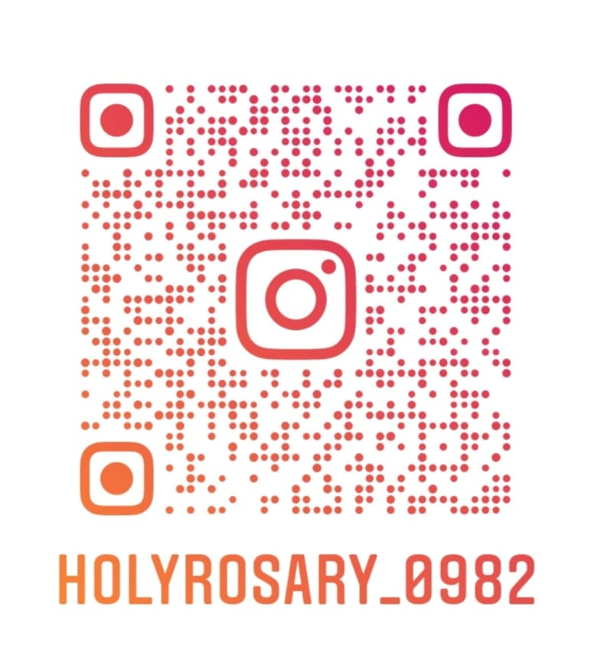shholyrosary@gmail.com
@HolyRosary_0982

Website:holyrosaryindependentschool.co.za

