  ------------- | HOLY ROSARY INDEPENDENT COMBINED SCHOOL
 | 2026 YEAR PLAN
 | THEME: “Do whatever He tells you, Believers free to serve”
JANUARY | Thursday: 1 | New Year’s Day
JANUARY | Monday: 5 | Matric, Admin & Staff reopens
JANUARY | Monday:12-13 | School reopens for teachers: Retreat & Meetings
JANUARY | Wednesday:14 | School reopens for learners & Orientation Day
JANUARY | Monday:16 | Presentation of PS to new educators
JANUARY | Thursday:22 | G12s Parents meeting @16h00
JANUARY | Wednesday 28 | SGB meeting
JANUARY | Friday:30 | Opening Mass
FEBRUARY | Wednesday: 4 | Umalusi online, Site Visit
FEBRUARY | Friday: 6 | (Motivational talk all Staff - Staff meeting)
FEBRUARY | Friday: 13 | Valentines’ day celebration Pre-Foundation
FEBRUARY | Saturday: 14 | Retreat for the learners (Grades 4-12)
FEBRUARY | Friday: 20 | School Prize giving day (4th Term, Results)
FEBRUARY | Friday: 20 | Class teachers’ workshop @ 12h00
FEBRUARY | Saturday: 21 | Prefects Workshop
FEBRUARY | Thursday: 26 | G10s Parents meeting
FEBRUARY | Friday: 27 | Fun Day
FEBRUARY | Saturday: 28 | Challenge Weekend G12s
MARCH | Thursday: 5 | Parents Meeting Grades R to 7 @ 16h00
MARCH | Friday:6 | Principals & SMT workshop@ 13h45-15h00
MARCH | Friday:5-7 | G12s Career Guidance (Up university)
MARCH | Thursday:19 | Feast of St. Joseph
MARCH | Thursday:19 | Parents meeting (8 & 9)
MARCH | Saturday:21 | Human Rights Day
MARCH | Friday:27 | School closing 1st Term
APRIL | Friday:3 | Good Friday
APRIL | Monday: 6 | Family Day
APRIL | Wednesday:8 | School opening 2nd Term
APRIL | Saturday:18 | Challenge Weekend G11s & Outreach program
APRIL | Tuesday:21-24 | General campaign (Safety)
APRIL | Monday:27 | Freedom Day Observed
MAY | Friday:1 | Workers Day
MAY | Friday:8 | Crèche Pyjamas Day
MAY | Saturday:9 | Challenge Weekend G10s
MAY | Wednesday:13 | Feast of Mary Mazzarello
MAY | Thursday:14 | Fire Drill
MAY | Wednesday:20 | SGB meeting
MAY | Thursday:21 | G11s Parents meeting @16h00
MAY | Friday:22 | Gratitude feast (Mary help of Christians anticipated)
MAY | Saturday:23 | Challenge Weekend G9s
MAY | Saturday:30 | Athletics day
JUNE | Thursday:4-5 | Parents Consultation Meeting (G6,7s,)
JUNE | Saturday:6 | Challenge Weekend G8s
JUNE | Friday:12 | Crèche Vintage Dressing
JUNE | Tuesday:16 | Youth Day
JUNE | Friday:26 | School Closing 2nd Term
JUNE | To be communicated | G12s Camp
JULY | Saturday:18 | Mandela Day
JULY | Tuesday:21 | School Opening 3rd Term
AUGUST | Saturday:1 | Challenge Weekend G6 & 7
AUGUST | Friday:7 | National Women’s Day (HRS)
AUGUST | Saturday:8 | Crèche Sports Day observed
SEPTEMBER | Friday: 4 | Crèche Casual day
SEPTEMBER | Saturday: 5, 12, 19 | Interviews
SEPTEMBER | Wednesday: 16 | Fire Drill
SEPTEMBER | To be communicated | G12 Farewell
SEPTEMBER | Wednesday: 23 | School Closing 3rd Term & teachers Day for HRS

OCTOBER
OCTOBER | Monday: 6 | School Opening 4th Term
OCTOBER | Wednesday: 7 | Holy Rosary Feast
OCTOBER | Friday:23 | Careers Day
OCTOBER | Friday:30 | School Concert
OCTOBER | To be communicated | G12s Camp
NOVEMBER | Friday: 6 | Crèche (Children’s Day & Pizza Day)
NOVEMBER | Wednesday:18 | SGB meeting
NOVEMBER | Saturday: 28 | Grade R Graduation Ceremony
DECEMBER | Wednesday: 9-11 | School Closing
DECEMBER | Wednesday: 16 | Day of Reconciliation
DECEMBER | Friday: 25 | Christmas Day
DECEMBER | Saturday: 26 | Day of Goodwill

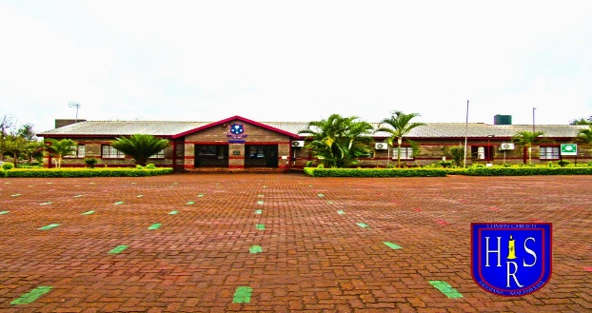

ETHOS
Holy Rosary School is a Catholic School.
We believe that “Education is a matter of the heart” (St. John Bosco).
Therefore, we promote a holistic formation in a family-like environment.
VISION
Holy Rosary School Educating Community aspires to build a faith-filled humanity
and to grow together in Gospel Values.
Jesus Christ, the Good Shepherd, is at the centre of our School Community.
Therefore, our approach to all aspects of life will be of affirming with respect,
the personal dignity and equality of each member with its unique qualities
and its cultural, racial and religious differences and needs.
MISSION
• We strive to develop a holistic approach, characterised by strong academic performance, moral development, spiritual maturity and physical growth.
• We encourage self-reliance, integrity, accountability, responsibility and self-discipline.
• We always work with diligence and excellence, through quality education nurtured by dedicated staff, learners, parents and collaborators.

